Exp No. 03 Date: 14-15/10/2021

**Stack and Queue: Array Implementation**

**Aim:** Implementation of Stack and Queue using arrays.

**Theory**:

**Stack:** A stack is a linear data structure that follows the principle of Last in First out (LIFO). This means the last element inserted inside the stack is removed first.

Mainly the following three basic operations are performed in the stack:

1. **Push:**Adds an item in the stack. If the stack is full, then it is said to be an Overflow condition.
2. **Pop:** Removes an item from the stack. The items are popped in the reversed order in which they are pushed. If the stack is empty, then it is said to be an Underflow condition.
3. **Peek or Top:** Returns the top element of the stack.
4. **isEmpty:**Returns true if the stack is empty, else false.
5. **isFull:** Returns true if the stack is full, else false

Stack :

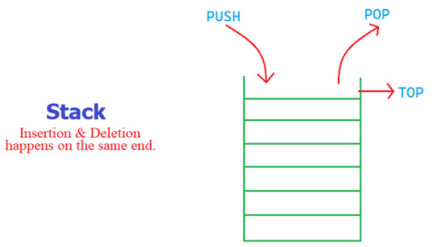

**Applications of stack:**

* [Balancing of symbols](https://www.geeksforgeeks.org/check-for-balanced-parentheses-in-an-expression/)
* [Infix to Postfix](https://www.geeksforgeeks.org/stack-set-2-infix-to-postfix/) /Prefix conversion
* Redo-undo features at many places like editors, photoshop.
* Forward and backward feature in web browsers

**Implementation:**   
There are two ways to implement a stack:

* Using array
* Using linked list

[**Queue:**](http://en.wikipedia.org/wiki/Queue_%28data_structure%29) Like [Stack](https://www.geeksforgeeks.org/stack-data-structure-introduction-program/), [Queue](http://en.wikipedia.org/wiki/Queue_%28data_structure%29)is a linear structure which follows a particular order in which the operations are performed. The order is **F**irst **i**n **F**irst **o**ut (FIFO).  A good example of queue is any queue of consumers for a resource where the consumer that came first is served first.   
The difference between stacks and queues is in removing. In a stack we remove the item the most recently added; in a queue, we remove the item the least recently added.

**2 pointers are maintained:**

**Front:**Get the front item from queue.   
**Rear:** Get the last item from queue.

**Operations on Queue:**   
Mainly the following four basic operations are performed on queue:  
**Enqueue:**Adds an item to the queue. If the queue is full, then it is said to be an Overflow condition.   
**Dequeue:** Removes an item from the queue. The items are popped in the same order in which they are pushed. If the queue is empty, then it is said to be an Underflow condition.

**PEEK:** displays first element of stack

**Logical representation Queue**

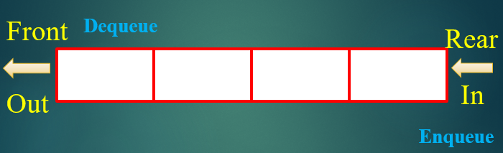

**Array implementation Of Queue**   
For implementing queue, we need to keep track of two indices, front and rear.

**Stack operation**

**Draw figures (refer ppt) and write code snippets for push,pop,**

**Program:**

**Output:**

**Queue:**

**Draw figures (refer ppt) and write code snippets for enqueue and dequeue**

**Program:**

**Output:**

**Conclusion**: Stacks and Queues were implemented using arrays in C.